**Sampling noise does not change with experience during simple choice**

Trinity Pruitt

mentors: Antonio Rangel and Brenden Eum

**Abstract.** A large body of work has shown that choice accuracy and reaction time in simple binary choices (e.g., apple vs. orange) are well described by sequential integration models such as the Drift-Diffusion-Model (DDM). In these models, noisy value samples are integrated over time in order to make a choice, and the quality of the choices decreases with the amount of noise. The goal of this project is to investigate if the amount of noise in the choice process decreases with experience, using data from simple choice experiments in which subjects make repeated binary choices over pairs of snack foods. The test is based on the predictions of the DDM. If noise decreases with the number of times an option has been evaluated over the course of the experiment, then choice accuracy should increase with the number of times the options have been encountered previously, and the reaction time curves should become steeper with previous experience. We tested these two predictions in two different datasets using hierarchical logistical regression for the choice data, and hierarchical linear regression for the reaction time data. We found no significant impact of previous experience on either choice accuracy or reaction times, which suggests that the noise in the value sampling process does not decrease over the course of a typical experiment, consisting of several hundred trials.

**Introduction**

A large body of work suggest that simple binary choices (such as, apple vs. orange) are made by repeatedly sampling and integrating noisy measures of value in the brain’s decision-making circuits, in order to estimate which option is best and make a final decision (Krajbich, Armel, & Rangel, 2010). The fact that the value samples are noisy implies that the choice process is noisy, and the larger the sampling noise the larger the amount of randomness in choice. The algorithmic nature of these choices has been shown to be well described by sequential integration models such as the Drift-Diffusion-Model (DDM).

An open question in the neuroeconomics literature is to understand how the choice algorithm changes with experience. One natural hypothesis is that as subjects gain experience in evaluating options, the noise in the decision process should decrease, with a concomitant gain improvement in the decision quality.

A natural hypothesis about how experience affects simple choices comes from the DDM. A critical parameter of the model is the size of the noise in the value sampling process. In this project we use experimental data on simple food choices to test the hypothesis that the amount of sampling noise decreases as subjects become more familiar with the choice stimuli.

**Theory**

The goal of this project is to test this hypothesis using data from simple choice experiments in which subjects make repeated binary choices over stimuli, using the experimental task from depicted in Figure 1 (Smith & Krajbich, 2018). Subjects provide ratings of their desire to eat various snack items using a Likert scale. Subjects were presented with two to four previously rated food items and were asked to choose which they would like to eat most at end of the experiment. Here, data analysis was restricted to the two-food task.

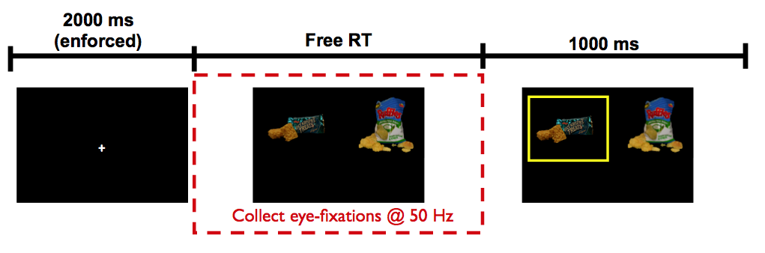

Fig.1. Experimental task. Subjects rate their desire to eat the snack on a Likert scale. Subjects chose between two food items on the two-food task. Subjects were given free reaction time as eye fixations were recorded. Subjects chose the left or the right item.

*Note*. Krajbich, I., Armel, C. & Rangel, A. Visual fixations and the computation and comparison of value in simple choice. *Nat Neurosci* 13,1292–1298 (2010). https://doi.org/10.1038/nn.2635. Copyright Nature Neuroscience.

DDMs are used to describe how humans make these types of simple decisions., as depicted in Fig. 2, Every trial, a relative decision value (RDV), denoted by W, is computed. The evolution of this signal is given by

W(t + dt) = W(t) + v * dt + n (1)

where t denotes time from the start of the decision, dt is a time step used in simulating the model,, v is the mean drift rate, and n is Gaussina white noise. The mean drift rate is propotional to the value different of the left and right items, as measured by the rating scale. The RDV starts at a/2, and a choice is made the first time that it crosses one of the fixed barriers: choice = left if the top barrier is crossed, and choice = right if the bottom barrier is crossed. As depicted in the figure, the model makes predictions about the probability of choosing left, and the distribution of reaction times, for any value of the mean drift rate *v*.

The main hypothesis to be tested in this project is that as subjects gain experience in evaluating options, the noise of the sampling process should decrease, which would result in an improvement in the quality of decisions, as well as faster choices. .

We validated this hypothesis by simulating choice data using the DDM for different amounts of noise. The results are shown in Figure 3.

Fig.2. DDM. DDM representing the observations along the y axis and the upper line is the threshold barrier for the correct choice, barrier a, and the lower line is the threshold barrier for theincorrect choice, barrier 0. The middle black horizontal line represents time. The thin jagged line represents the noise in the brain on a single trial when evidence is accumulated. The speed of accumulation is determined by the drift rate, v. The upper blue line and lower red line indicates reaction time. A decision is made when the trajectory of the jagged lines reaches either a or 0. t0 is the gap of time where the stimulus is presented, and the subject starts accumulating evidence.

Figure 3a shows the impact of noise on choices. As the noise (denoted by sigma) increases, the choice curve becomes steeper, so the subject becomes more able to choose the best item reliably. Figure 3b shows the impact of noise on reaction time: as the noise increases, reaction times become faster but also less sensitive to the value differences.

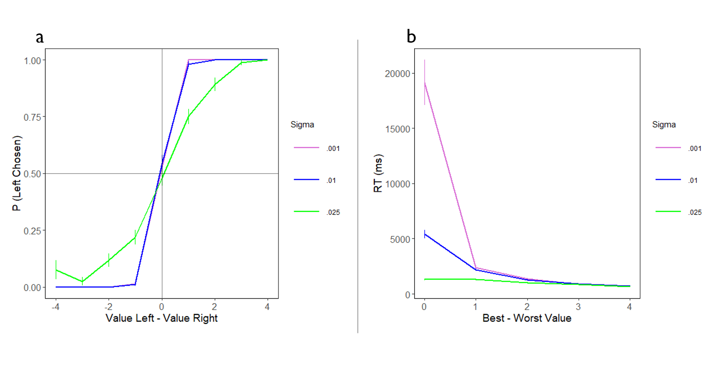

Fig. 3. (a) Simulated choice curve. Representation of simulations at various sigma levels for the probability that the subject chose left. In this case, sigma captures the amount of noise in the decision-making process. The magnitude of sigma determines the number of errors in the process. (b) Simulated reaction time curve. Representation of simulations at various sigma levels for reaction times.

**Methods**

The experimental task consisted of subjects rating their desire to eat various snack items. An extreme dislike of the food was more negative, and an extreme liking of the food was more positive and were free to take time deciding between items. Subjects were calibrated to an eye tracker and their fixations were recorded throughout the experiment. The task itself consisted of subjects being presented with two previously rated food items and were asked to choose which they would like to eat most at end of the experiment. Only positively rated food presented (which the value was rated greater than zero). Food items were randomly selected; however, no item could be shown greater than seven times and value difference could not exceed five for the Smith and Krajibich (2018) data set.

Two data sets were used for this analysis. Smith and Krajbich (2018) consisted of 200 trials, 44 subjects, and items were rated on a Likert scale from -10 to 10. Eum and Rangel (2021) consisted of 400 trials, 50 subjects, and items were rated on a Likert scale from -5 to 5.

These two predictions were tested based on the predictions of the aDDM in two different datasets using hierarchical logistical regression for the choice data, and hierarchical linear regression for the reaction time data. The data sets were split into variables representing median number of times the item is seen for the experiment per subject and compared how many times the item was presented less than the median and the frequency of the item that was greater than the median. Using the statistical software R, the data analyses were ran to carry out the following two tests: (1) conducted logistic regression to test if the probability of choosing the best item, controlling for their latent true value, increases with the number of times that the choice options have been encountered before, as should be the case if sampling noise decreases with familiarity, and (2) conducted linear regression to test if the reaction time, controlling for the latent true value of the options, decreases with the number of times that the options have been encountered before, as it should. The data was plotted to model group data and individual subject data, plotting the probability of left chosen against the value of the options and the reaction time against the value of the options. The group data consisted of the average of all subject's reaction times and choices. Individual data plotted each subject in their own panel and comparing the choices and reaction times individually.

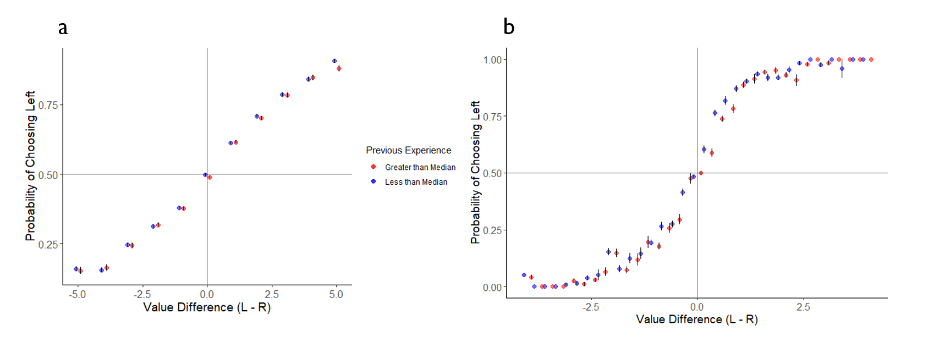

Fig. 4(a). Smith & Krajbich (2018) choice curve. Fig 4(b). Eum & Rangel (2021) choice curve. (a) and (b) Shows the probability the subject chose left on the y axis and the value difference between items on the x axis. The red represents the previous number of items chosen was greater than the median of how many times the item was presented in the experiment. The blue represents the previous number of items chosen was less than the median of how many times the item was presented in the experiment. The little black lines are the standard error bars. (a) Spaced the values by 1 unit. (b) Spaced the values by 0.25 units.

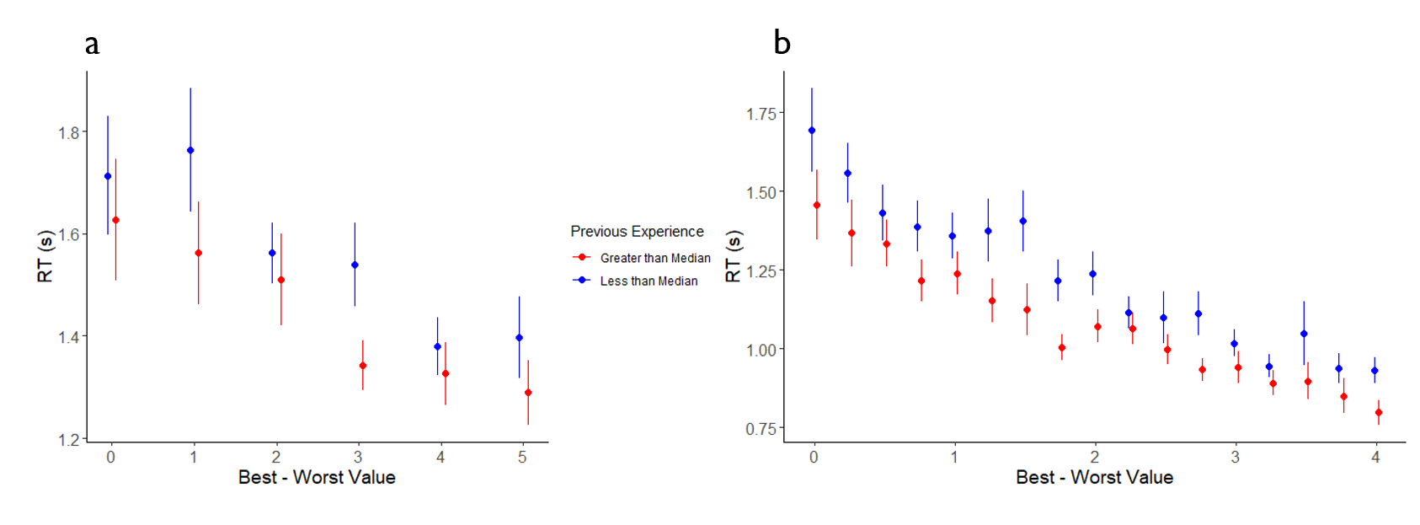

Fig. 5(a). Smith & Krajbich (2018) reaction time curve. Fig 5(b). Eum & Rangel (2021) reaction timecurve. (a) and (b) Shows the reaction time in seconds on the y axis and the absolute value difference between items on the x axis. The red represents the previous number of items chosen was greater than the median of how many times the item was presented in the experiment. The blue represents the previous number of items chosen was less than the median of how many times the item was presented in the experiment. The lines are the standard error bars. (a) Spaced the values by 1 unit. (b) Spaced the values by 0.25 units.

**Table 1*. Results of hierarchical regression models***

|  |  |  |  |  |  |
| --- | --- | --- | --- | --- | --- |
|  | | Smith & Krajbich (2018) data | | Rangel & Eum (2021) data | |
| Figure | Variable | Est. | SE | Est. | SE |
| Logistic | Intercept | 0.12 | 0.05 | 0.25 | 0.08 |
|  | Left – Right Rating | 0.17 | 0.03 | 0.53 | 0.11 |
|  | Previous Experience | 0.10 | 0.07 | 0.16 | 0.10 |
|  | Interaction | 0.03 | 0.02 | 0.13 | 0.10 |
| Linear | Intercept | 0.71 | 0.08 | 0.50 | 0.07 |
|  | Best – Worst Rating | 0.07 | 0.02 | 0.12 | 0.02 |
|  | Previous Experience | 0.14 | 0.08 | 0.19 | 0.04 |
|  | Interaction | 0.04 | 0.02 | 0.04 | 0.02 |

*Note.* This presents the estimate and standard error of the hierarchical models. The variables Left - Right Rating and Best - Worst Rating were statistically significant. However, the interaction of previous experience and value rating did not yield statistically significant results.

**Conclusion**

Simple binary choices are made by sampling stimuli and fusing noisy measures in the brain until a threshold is crossed and a decision is made. DDMs are useful because it allows us to explain why these choices are made to predict future choices and response times. The noise of the sampling process did not significantly change, with no natural improvement in the choice process, therefore the hypothesis was not supported.

Findings and possibilities for future research. Limitations of this analysis include the data set Smith and Krajbich (2018) did not have sufficient data regarding eye fixations. The necessary variables required to run an aDDM simulation that were lacking were transition and latency. Therefore, the simulations were ran with data from Eum and Rangel (2021) but performed on data from a subject from Smith and Krajbich (2018). These findings can be tested and extrapolated to other binary decisions humans make. Noise difference may not express a relationship with binary choice but length of time necessary to evaluate choices could be a possibility.

**References**

(1) Krajbich, I., Armel, C. & Rangel, A. Visual fixations and the computation and comparison of value in simple choice. *Nat Neurosci* 13,1292–1298 (2010). https://doi.org/10.1038/nn.2635

(2) Smith, S. M., & Krajbich, I. (2018). Attention and choice across domains. *Journal of Experimental Psychology: General*, *147*(12), 1810–1826. <https://doi.org/10.1037/xge0000482>

(3) Matzkin, R. L. (1992). Nonparametric and distribution-free estimation of the binary threshold crossing and the binary choice models. *Econometrica: Journal of the Econometric Society*, 239-270.

(4) Bitzer, S., Park, H., Blankenburg, F., & Kiebel, S. J. (2014). Perceptual decision making: drift-diffusion model is equivalent to a Bayesian model. *Frontiers in Human Neuroscience*, *8*. <https://doi.org/10.3389/fnhum.2014.00102>

(5) Eum, B., & Rangel, A. (2021). Peripheral visual information halves attentional choice biases [Unpublished manuscript]. Humanities and Social Sciences, California Institute of Technology.